Home Work:

How to Create an ER Diagram in SQL Developer

Contents

1. Open SQL Developer 2

2. Open the Data Modeler Browser 2

3. Input the Information from the Data Dictionary 2

4. Choose the Books Connection 3

5. Choose the Books Schema 3

6. Choose the Tables to Import 3

7. Click Finish 4

8. Click Close 4

# Open SQL Developer

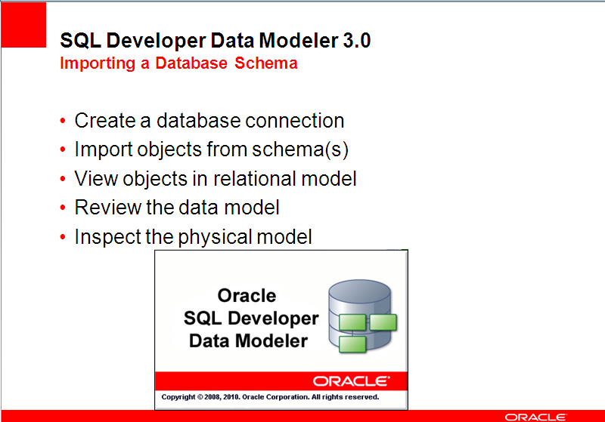

# Open the Data Modeler Browser

Select View>Data Modeler>Browser

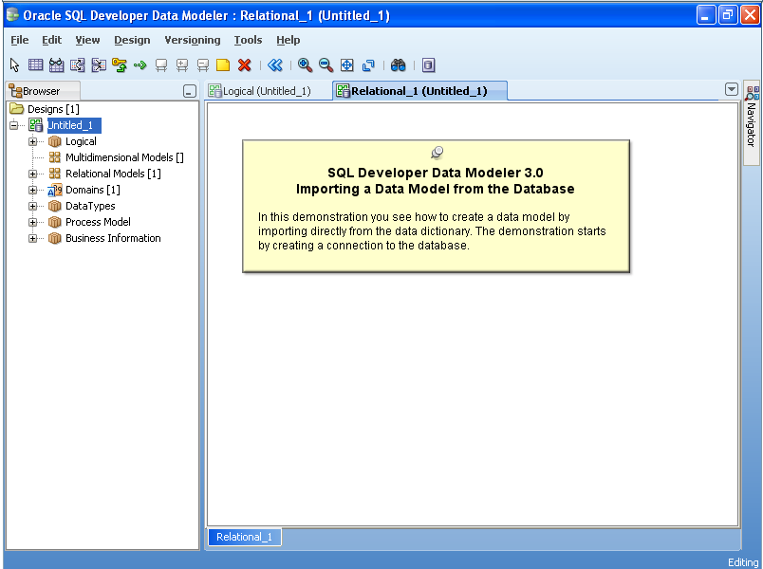

# Input the Information from the Data Dictionary

Select File>Data Modeler>Import>Data Dictionary

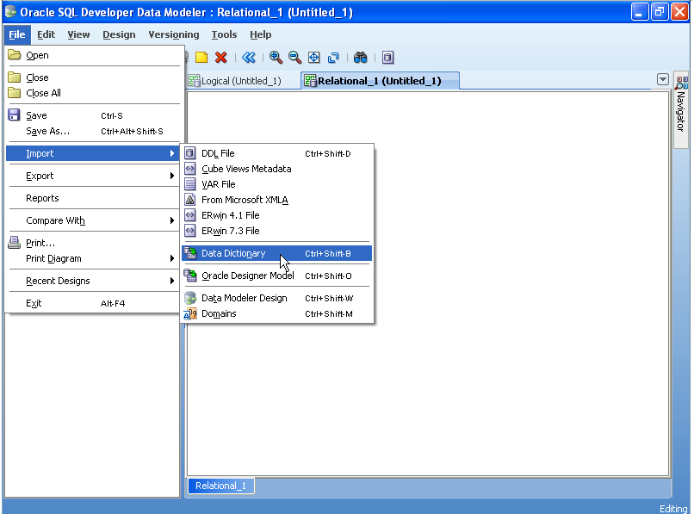

# Choose the mybooks schema

Double Click the mybooks Schema at the top of the window

When the Next button at the bottom becomes enabled click Next

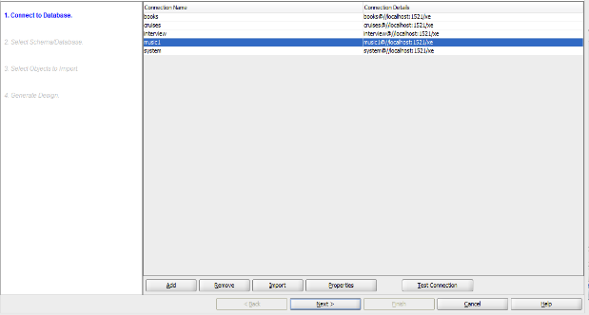

# Choose the mybooks Schema

Select the mybooks Schema

When the Next button at the bottom becomes enabled click Next

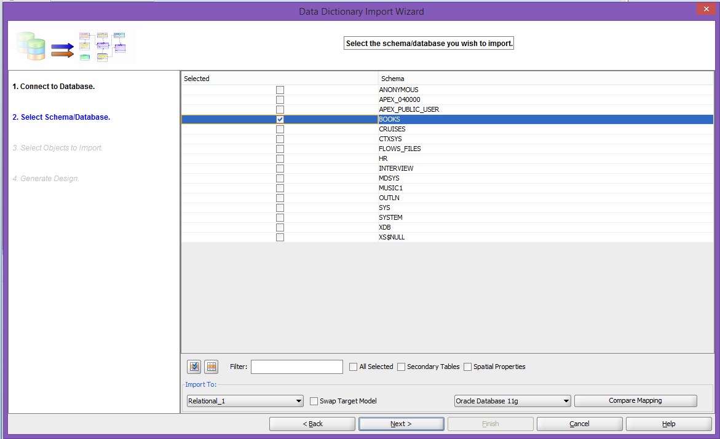

# Choose the Tables to Import

Place a check mark next to the following tables: Customers, Orders, OrderItems, Books, BookAuthor, Author, Publisher, Promotion.

When the Next button at the bottom becomes enabled click Next

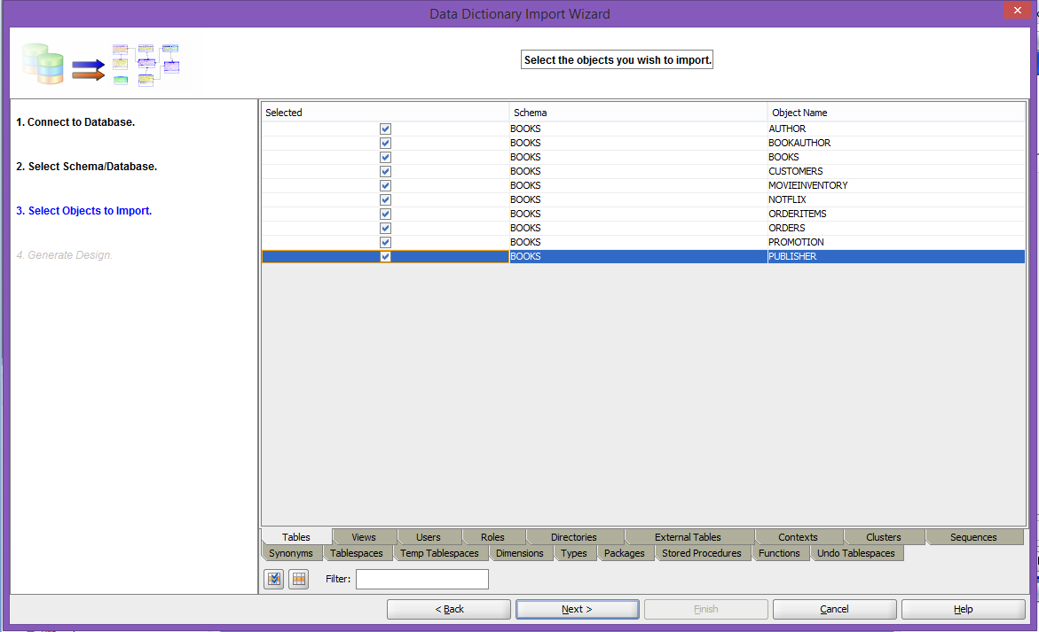

# Click Finish

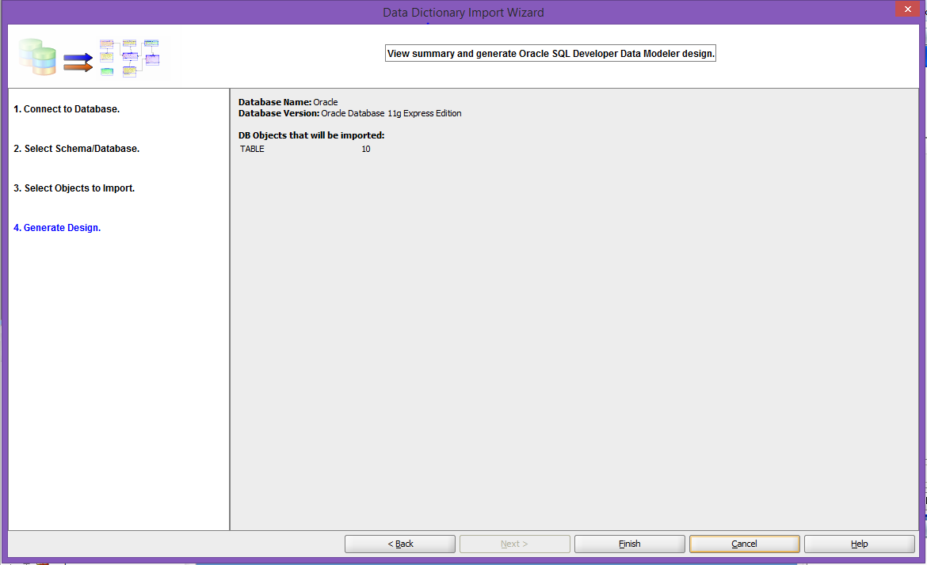

# Click Close

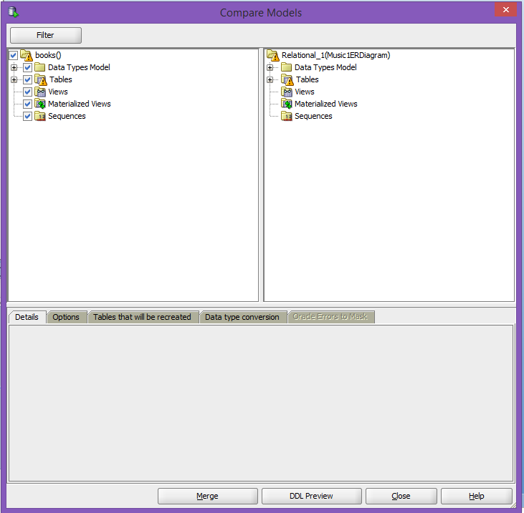

# Save Model

Select File>Data Modeler>Save As (type in a name) and click save.

# Arrange the Model into this pattern

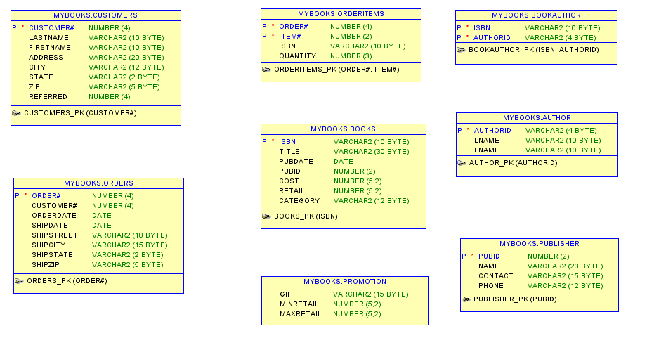

# Save Model

Select File>Data Modeler>Save As (type in a name) and click save.